Progress report of work done through Child Rehabilitation Camp set up in Jawhar for eradication of malnutrition

Introduction:
According to the 2011 census, the total population of Palghar district is 29,90,116 out of which tribal population is 11,18,008 (37.39%). Palghar district has a total of 8 Talukas and covers 1,008 villages. Among them are Dahanu, Talasari, Wada, Vikramgad, Jawhar and Mokhada. Palghar and Vasai are partial schedule areas. There are 876 villages, 3,818 padas and 477 gram panchayats in the scheduled area. Palghar district has a literacy rate of 66.65%, male literacy is 72.23% while female literacy is 59.28%. Jawhar district has 10 rural hospitals, 2 sub-district hospitals, 46 primary health centres and 305 sub-centres.

In 2018-19, 7,412 moderately malnourished (MAM) and 1,868 severely malnourished (SAM) children were found in Palghar District. Jawhar, Mokhada, Talasari, Palghar and Vikramgad talukas have the highest number of malnourished children and infant mortality. After the matter came to the notice Samarthan conducted on-site Panchnama of Anganwadis, Primary Health Centers and Rural Hospitals in these 5 talukas. We also surveyed 40 out of 46 primary health centres. The key outcomes of the assessment are as below.
- Out of these 40 primary health centres, there was no accommodation for doctors and staff in 11 primary health centres.
- There was no water supply in 4 primary health centres and no maternity ward in 4 primary health centres.
- In all the talukas of Palghar district, there were unfilled vacancies in all the important posts of Maternal and Child Care Officer, Additional District Health Officer, Assistant District Health Officer.
- There were 19 vacancies for Medical Officer Group-A and Group-B.
- There was only one District Surgeon in the district and he had no office or staff.
- There were 817 posts of medical officers and staff in the 40 primary health centres surveyed out of which 179 posts were vacant.

Malnutrition is highest in tribal areas as compared to the rest of Maharashtra.
- In the period of 6 months from June to November 2021 in Maharashtra, 3,67,89,784 children were weighed. Out of which 34,97,789 children were found malnourished. The incidence of malnutrition in children was 9.51%.
- In the tribal district of Maharashtra, 53,30,625 children were weighed, out of which 10,83,587 children were found to be malnourished. The rate of malnutrition was 20.33%.
- 10 lakh 56 thousand 259 children were weighed in Palghar district, out of which 2,48,476 children were found malnourished. The rate of malnutrition was 23.52%.
- 96,127 children from tribal communities were weighed in Palghar district out of which 2 lakh 39 thousand 307 children were found malnourished. The incidence of malnutrition was as high as 24.92%.

Establishment of Child Rehabilitation Center in Jawhar with Support Initiative:
After the massive increase in malnutrition in the remote taluka of Jawhar-Mokhada, The foundation stone for ‘'Baal Sanjeevan Chhavani' was laid on January 18, 2017, at Jawhar. After that, on July 26, 2019, this child rehabilitation camp was built. The first malnourished girl child was admitted to this camp on August 19, 2019.
Preventing malnutrition through centre
Since the establishment of the center, health camps have been organized every month. To date, more than 97 health camps have been organized in three talukas namely Jawhar, Mokhada, Wada and Vikramgad. 6190 children received treatment and nutritious food through these camps. In addition, 435 children are admitted to the camp with their mothers for treatment from year 2018 to 2023. Based on the statistics of malnourished children received from the government survey, affected children and their mothers are called for treatment in the centre. Due treatment and care is provided to them. If necessary, they are referred to a speciality hospital for treatment. A record of this is being kept and the registration is done after the admission of the children. Information about the Child's Name, Mother's Name, Address, Contact Number, Age, Weight, Height, Other Ailments etc. is maintained and its progress is checked every week.
The main objective of the camp is to prevent the increasing malnutrition among tribal children. This is the first post-independence social initiative to overcome malnutrition. Therefore, this camp strives to develop a template not only for other districts but also for every malnourished state. This also works to address the root causes of malnutrition, such as hunger and unemployment. Volunteers are constantly working to prevent distress migration for employment. The center is trying to create awareness in the community about education and health, to avail the benefits of various schemes of the government, and for the overall development of the tribal populace.

Specialist doctors and staff engaged to conduct health camps, and the eminent doctors in the community have been of great help in this endeavour. Many doctors have been involved in this work. Among them are Dr. Ashish Bhosale from Mumbai and Dr. Varsha Bhosale, Dr. Vinay Patil and Dr. Varsha Patil, Dr. Jayashree Patil, Dr. Prachi Shah, Dr. Ashish Thackeray and Dr. Reshma Thackeray. They come to the camp every month with all their resources and staff. If need be, many children are referred to major hospitals. As a result, the Child Rehabilitation Camp has successfully treated and operated on more than 50 children suffering from chronic diseases to date.

Health Camp at Child Rehabilitation Camp:
In the last two and a half years, more than 30 health camps have been organized in the child rehabilitation camp. The work done for malnourished children during the COVID-19 pandemic period is unique. The following is the list of health camps conducted in the last months.

- Child Rehabilitation Camp, Jawhar (July 18, 2023): A total of 104 children from Jawhar taluka and 24 children from Mokhada were examined in this health camp. For this, Dr. Varsha Bhosale and Dr. Ashish Bhosale examined the health of these children. 36 children in Jawhar and 13 in Mokhada were severely malnourished (SAM). 37 children from Jawhar and 9 children from Mokhada were found to be moderately malnourished. 7 children from Jawhar and 2 children from Mokhada were of normal weight. 7 out of 80 children in Jawhar and 3 out of 24 children in Mokhada were referred for further treatment. 3 children each from Jawhar and Mokhada were admitted to the camp.

- Child Rehabilitation Camp, Ambadi (August 29, 2023): It had 85 children from Jawhar taluka in this health camp. Dr. Varsha Patil and Dr. Vinay Patil examined the health of these children. Of these, 42 children were found to be severely malnourished (SAM) and 34 children were found to be moderately malnourished (MAM). Only 9 children were of normal weight. 7 of them were referred to a major hospital for further treatment. 2 children were admitted to the camp for treatment.

- Child Rehabilitation Camp and Navjivan Patient, Ambadi (September 12, 2021): 25 children from Mokhada taluka were examined in this health camp. Dr. Varsha Patil and Dr. Vinay Patil examined the health of these children. Of these, 18 children were found to be severely malnourished (SAM) and 4 children were found to be moderately malnourished (MAM). 3 children were of normal weight. None of the children had to be referred to a major hospital for further treatment nor admitted for treatment.

- Child Rehabilitation Camp and Navjivan Patient, Ambadi (September 26, 2022): 61 children from Jawhar taluka were checked in this health camp. Dr. Varsha Patil and Dr. Vinay Patil examined the health of these children. Of these, 44 children were found to be severely malnourished (SAM) and 12 children were found to be moderately malnourished (MAM). Only 4 children were of normal weight. None of the children had to be referred to a major hospital for further treatment. However, 11 of them were admitted to the camp for treatment.

- Child Rehabilitation Camp at Navjivan Hospital, Ambadi (October 10, 2021): 28 children from Mokhada taluka was checked in this health camp. Dr. Varsha Patil and Dr. Vinay Patil examined the health of these children. Of these, 18 children were found to be severely malnourished (SAM) and 7 children were found to be moderately malnourished (MAM). Only 3 children were of normal weight. None of the children had to be referred to a major hospital for further treatment and had to be admitted to the camp for treatment.

- Child Rehabilitation Camp and Talwada Primary Health Center, Vikramgad (October 17, 2023): 42 children from Vikramgad taluka were screened in this health camp. Dr. Varsha Bhosale and Dr. Ashish Bhosale examined the health of these children. Out of them, 20 children were found to be severely malnourished (SAM) and 18 children were found to be moderately malnourished (MAM). Only 4 children were of normal weight. 2 of them were referred to a major hospital for further treatment. However, not a single child had to be admitted to the camp for treatment.

- Child Rehabilitation Camp at Navjivan Hospital, Ambadi (October 31, 2023): 85 children from Jawhar taluka were checked in this health camp. Dr. Varsha Patil and Dr. Vinay Patil examined the health of these children. Of these, 54 children were found to be severely malnourished (SAM) and 23 children were found to be moderately malnourished (MAM). Only 8 children were of normal weight. None of the children had to be referred to a major hospital for further treatment and had to be admitted to the camp for treatment.

- Child Rehabilitation Camp and Talwada, Primary Health Center, Vikramgad (November 19, 2023): 109 children from Mokhada taluka participated in this health camp. Dr. Varsha Bhosale and Dr. Ashish Bhosale examined the health of these children. Of these, 42 children were found to be severely malnourished (SAM) and 54 children were found to be moderately malnourished (MAM). 13 children were of normal weight. Out of them, 2 children had to be referred to a big hospital for further treatment but no child had to be admitted to the camp for treatment.

- Child Rehabilitation Camp at Navjivan Hospital, Ambadi (December 12, 2021): 27 children from Mokhada taluka were checked this health camp. Dr. Varsha Patil and Dr. Vinay Patil examined the health of these children. Of these, 13 children were found to be severely malnourished (SAM) and 9 children were found to be moderately malnourished (MAM). Only 5 children were of normal weight. None of the children had to be referred to a major hospital for further treatment and had to be admitted to the camp for treatment.

- Child Rehabilitation Camp & Parli, Primary Health Center, Wada (December 19, 2022): 93 children from Wada taluka were checked in this health camp. Dr. Varsha Bhosale and Dr. Ashish Bhosale examined the health of these children. Of these, 22 children were found to be severely malnourished (SAM) and 53 children were found to be moderately malnourished (MAM). Only 18 children were of normal weight. 7 of them had to be referred to a major hospital for further treatment. However, not a single child had to be admitted to the camp for treatment.

- Child Rehabilitation Camp at Navjivan Hospital, Ambadi (January 2, 2022): This camp had 62 children from Jawhar taluka. Dr. Varsha Patil and Dr. Vinay Patil examined the health of these children, out of them, 40 children were found to be severely malnourished (SAM) and 14 children were found to be moderately malnourished (MAM). Only 8 children were of normal weight. One of the children had to be referred to a major hospital for further treatment. 5 children had to be admitted to the camp for treatment.

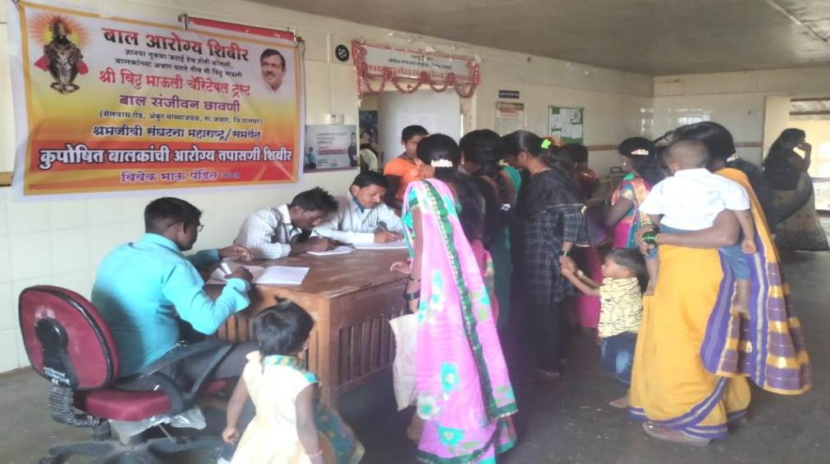
'Bal Sanjeevani Camp', Jawhar

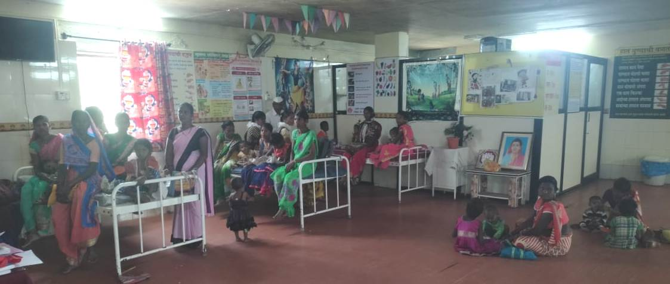
'Bal Sanjeevani Camp' Jawhar

Important Case Reports of Children Treated by 'Bal Sanjeevani Camp':

- Name: Ms. Poonam Gangu Mallesh Chaudhary:
Father's Name: Shri. Mallesh Mahadu Chaudhary,
Date of birth: November 10, 2016
Tribe: Warli
Date of Admission: August 19, 2019
Age years: 2 years 9 months,
weight: 6.00 kg. Gr. Height: 75. 2 cm
Belongs to: Morhanda, Tal. Mokhada, Dist. Palghar
Category: Acute malnutrition
Discharge on November 30, 2019
Weight: 7.7 kg Height 78.9 cm.
Case details: Poonam was the first girl to enter the camp. When she arrived at the camp, she was in the moderate malnutrition (MAM) category. She could not walk. The arms and legs were thin. Dr. Varsha Bhosale started treatment immediately. Her condition improved due to medication and proper diet. Gradually the girl came out of the malnutrition. Now with age, her weight and height are increasing. She has parents and a sister. But the family is landless and does not have their own home to live in. The girl currently lives with her aunt. Her parents support her.

- Name: Ms. Archana Krishna Bhoye:
Belongs to: Jawhar, Palghar district
Tribes: Katkari, Primitive Tribes.
Family: Below poverty line, parents farm for subsistence.
Age 4 years: Weight: 7.1 kg. Acute Malnutrition (SAM)
Diagnosis: Abdominal tumour and severe malnutrition
When did you get the information? December 17, 2020
Admission for treatment: 21 days admission for treatment and surgery at Sion Hospital, Mumbai.
Case details: She underwent surgery at Sion Hospital, Mumbai and is now recovering.
She was admitted to Sion Hospital on December 19, 2020 and underwent surgery for the tumour. The girl was undergoing treatment at the hospital for 21 days. Now that her condition is improving, she is gaining weight.
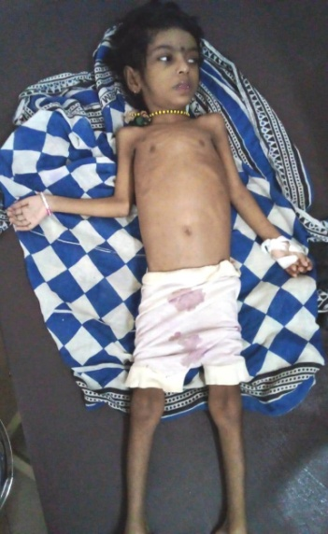
When we came to know about Archana, Sita Ghatal and other activists went to the girl's house, but her parents were not ready to take her to the hospital for treatment. The girl was found lying on the floor. Activists immediately enlisted the help of Dr. Marhad of 'Patangshah Cottage Hospital' Jawhar. He advised them to move her to Sion Hospital in Mumbai for this. The girl's parents were not ready to take Archana to Sion Hospital for treatment. However, the activists counselled the parents about the serious condition of the girl. After that, on the recommendation of the founder of 'Bal Sanjeevani Chhavani' Shri. Vivekbhau Pandit as well as a consultant and paediatrician Dr. Bhosale, was admitted to Sion Hospital. Her tumour was then surgically removed. During this time she was admitted for 21 days. She is now at home and her medicines have been provided through 'Bal Sanjeevani Chhawani'. Her diet is provided by Anganwadi. However, the activists of 'Bal Sanjeevani Chhawani' are keeping an eye on her health and now her condition is improving and she is gaining weight.

- Name: Ms. Rupesh Tukaram Khanjode.
Belongs to: Jawhar, Palghar district
Tribe: Warli
Family: Below the poverty line, parents migrate for subsistence.
Age 3 years: Weight: 6.2 kg.
Category: Acute Malnutrition (SAM)
Diagnosis: Tuberculosis (T.B.)
When did you get the information? February 16, 2020
Admission for treatment: Admitted to 'Bal Sanjeevani Camp' on February 19, 2020
How many days: Until February 27, 2020. (9 days)
Case details: The boy has recovered from tuberculosis and is now recovering well and weighs 14 kg. Has increased so much.
In the health camp held at 'Baal Sanjeevani Chhawani' Jawhar in February 2020
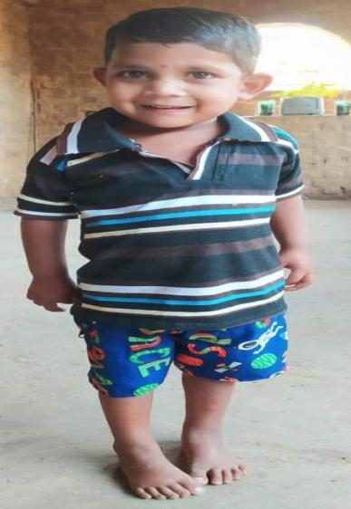
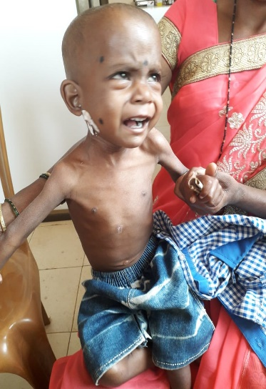
Ms. Rupesh Tukaram Khanjode was brought from Pimpakada, Jawhar for examination. Upon examination, he was suspected to have tuberculosis (T.B.). This suspicion was later confirmed when an X-ray of his chest was taken. He was diagnosed with tuberculosis. His family was not ready to admit him to the camp for treatment as his father had gone to Palghar taluka for employment. After calling and asking him, he told his wife, Rupesh's mother, to take responsibility and to handle the situation. The boy was severely malnourished (SAM). After explaining his condition to his mother, she was convinced to take follow up action. He was admitted to the camp for treatment. He was examined at Patangshah Cottage Hospital, Jawhar. He was kept in the camp for nine days. He was later released after explaining to his mother how to give him his medicine and how to feed him.
The Medical Officer of Jawhar Primary Health Center Dr. Kiran Patil was a great help. He had given the special responsibility of this child to Anganwadi worker and Asha. In addition, camp workers visited his home every week to inquire about his health. Today, Rupesh has overcome malnutrition and is free from tuberculosis. His weight has also increased. Importantly, now the boy eats all kinds of food.

- Name Ms. Vishwas Shriram Bhoye.
Belongs to: Nashera, Tal. Mokhada, Palghar district
Tribes: Katkari, Primitive Tribes.
Family: Below poverty line, parents work for subsistence.
Age: 2 years, Weight: 10.2 kg
Diagnosis: Axillary Cystic Hygroma
When did you get the information? March 15, 2021.
Admission for treatment: admitted to the Nair hospital on March 17, 2021.
Case details: His armpit surgery has been successful and his condition is improving.
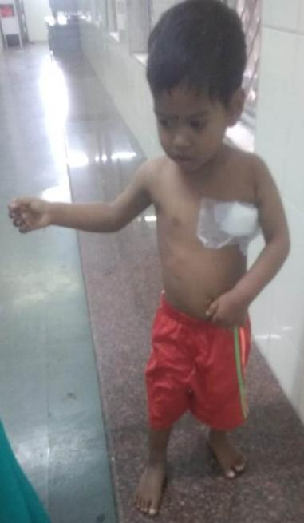
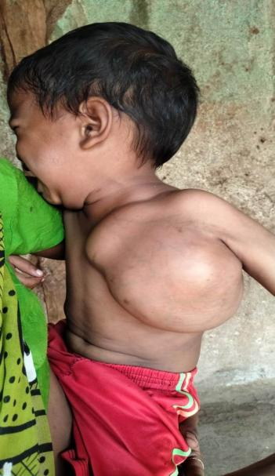
Vishwas Shriram Bhoye, age 2 years had a knot in his armpit from birth. Although she was not in pain, the knot was growing with the age. Immediately after receiving the information, Shri. Vivek Bhau asked the camp volunteers to visit Nashera. He later told his parents that he had to be rushed to a hospital. His parents were not ready for it as there were apprehensions about the expenses and potential loss of livelihood.
Dr. Varsha Bhosale extended all kinds of help in that regard. After being admitted to the hospital, his MRI was taken. Upon completing all the medical procedures he successfully underwent surgery at Nair Hospital on the knot of trust. Today, the his condition is stable and improving.

- Name: Ms. Mayank Vitthal Mahale:
Date of birth: March 2, 2018
Tribe: Konkana
Age: 3 years 8 months, weight: 9 kg. 800g Height: 87 cm, Category: Moderately malnourished (MAM), Anganwadi: Banana Pada, P. H. C: Sakur, Ta. Jawhar Dist. Palghar
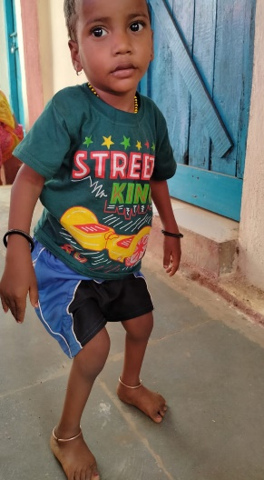 | Mayank used to sit when came to the camp but couldn’t stand or walk. After the treatment, he started to walk and is now completely out of malnutrition. | 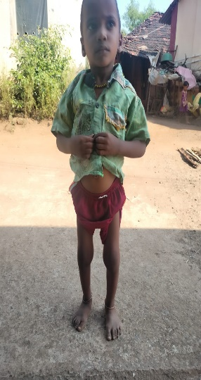

- Name: - Anushka Somnath Khulat:
Date of birth: April 18, 2018
Tribe: Warli
Age: 3 years 6 months, Weight: 6 kg. 100g.,
Height: 78.4 cm. M., Category: Acute Malnutrition (SAM), Ra. Coal Pada Ta. Jawhar,
Anganwadi Center: - Coal Pada, Pvt. Come on. Center: Nandgaon Tal: Jawhar,
Case details:
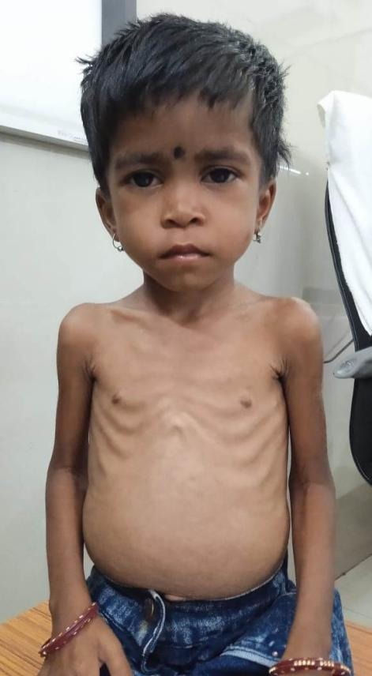 | On the advice of Vinay Patil, she was admitted to Jawhar's Cottage Hospital on November 1, 2021. She underwent X-ray and blood tests. She was x-rayed in two ways. Tuberculosis (T.B.) was diagnosed in the first X-ray. But in another X-ray, the doctor says that she did not have tuberculosis. Hence, it was recommended to do sonography, which was done as well. As it was Diwali, she was temporarily discharged from the hospital.
She was re-admitted to Cottage Hospital on Monday, November 8, 2021. After that, she was admitted to her camp for 25 days. Both, her treatment and her healthy diet, continued. Later, her parents took her home to farming. In the meantime, she had recovered. She went from severe malnutrition (SAM) to moderate malnutrition (MAM) and now has become normal with age-weight-height. |  | 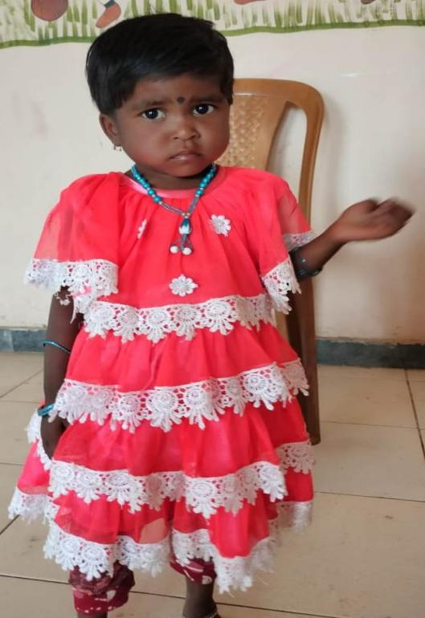

- Name: Ms. Rupali Ashok Taral:
Tribe: K-Thakur
Age: 1 year 6 months, weight: 5 kg. 500g
Category: Moderately malnourished (MAM), Ra. Taral Pada, Tal. Jawhar

Case details:
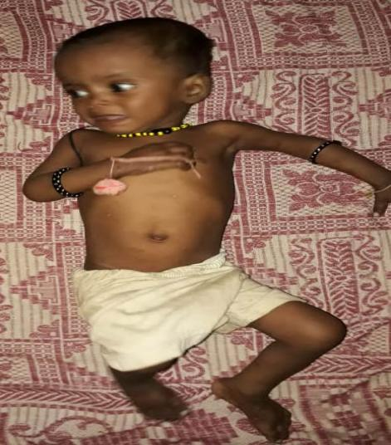 | The time when Rupali was found malnourished it was a lockdown during the pandemic. So we could not take malnourished children to the camp. Instead, we went to Taral Pada and camped. Madam Varsha Bhosle had come.
Rupali's brother, Rupesh was also found to be severely malnourished (SAM). We could not admit them, but gave them medicine and food at home and explained to their parents how to take food and medicine. Thereafter, both these children recovered from malnutrition. Today, their weight and height are normal according to their age. | 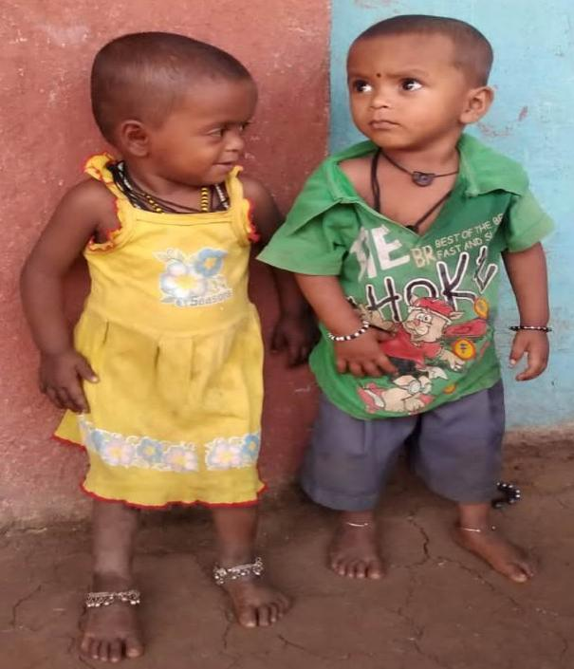

- Name: Ms. Rohit Pintu Ran
Father's Name: Shri. Pintu Ran, will remain: Ghoti, Katkari Wadi, Tal. Igatpuri, District Nashik.
Tribe: Katkari.
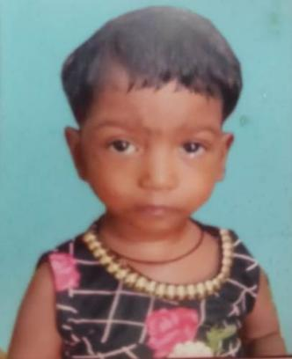 | Rohit had a brain problem. Following the guidance of Varsha Patil, he was taken to Nair Hospital in Mumbai for treatment. He is now recovering. | 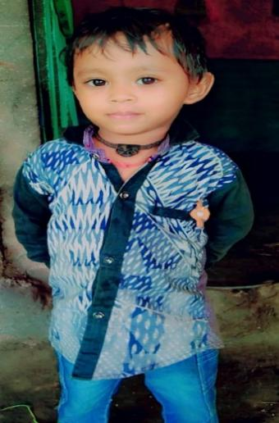
- Name: Ms. Priya Nilesh Bendkule
Tribe: Warli
Belongs to: Waki, Taluka Vikramgad District Palghar

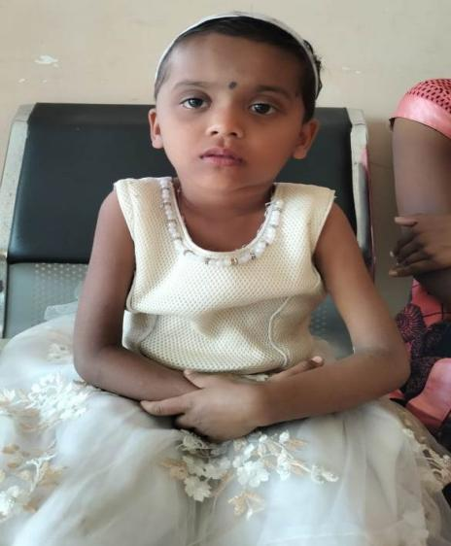 | Priya's eyesight was gone. Dr. She was referred to Nair Hospital in Mumbai under the guidance of Varsha Patil. She had to undergo surgery (OPERATION). She has been successful and her vision is now fully restored. She was severely malnourished at the time of admission. Today, she has gained weight with age and has become normal.
The 'Baal Sanjeevani Kendra, Jawhar' has played an important role in the survival of the poor tribals during the difficult period during the lockdown phases of the pandemic and even after the lifting of the ban. This work shall continue tirelessly in the days to come.
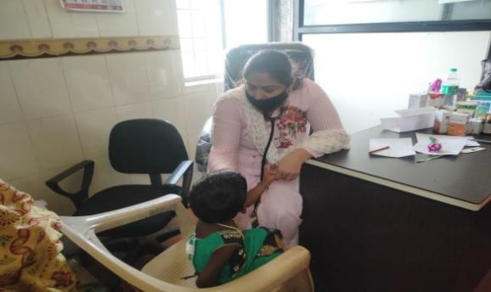 | 'Bal Sanjeevani  Health  Camp', Jawhar | 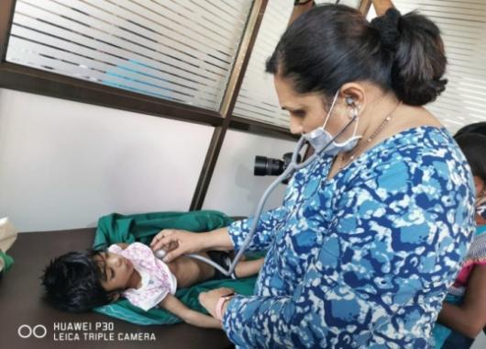
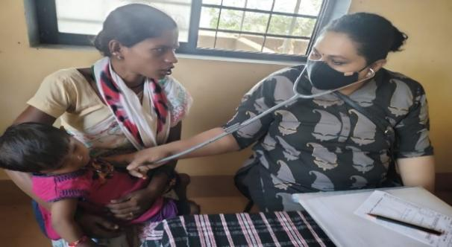 | 'Bal Sanjeevani  Health  Camp', Jawhar | 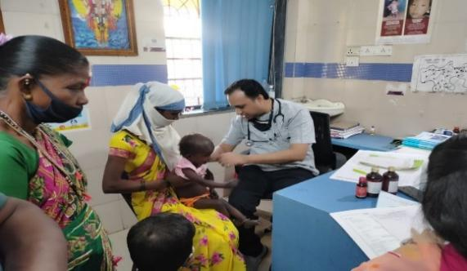
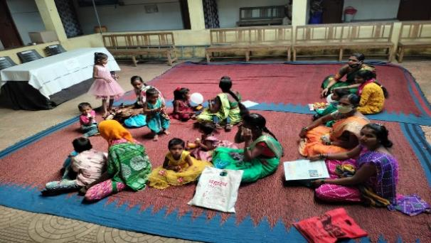 | 'Bal Sanjeevani  Health  Camp', Jawhar | 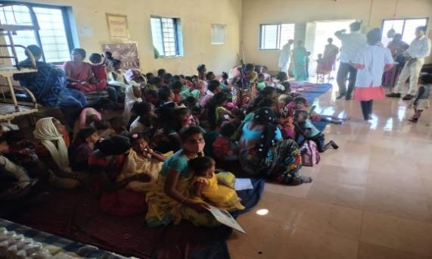
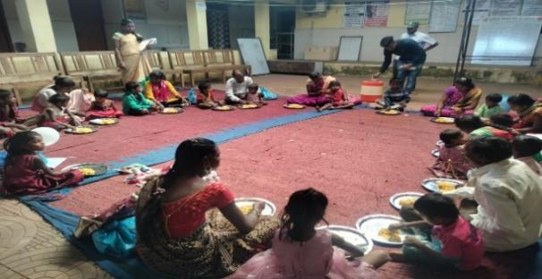 | 'Bal Sanjeevani  Health  Camp', Jawhar | 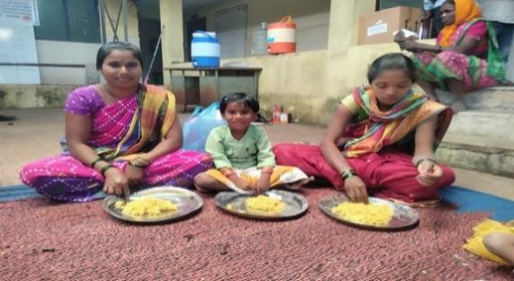
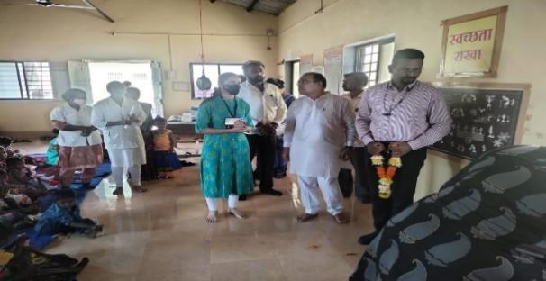 | 'Bal Sanjeevani  Health  Camp', Jawhar | 